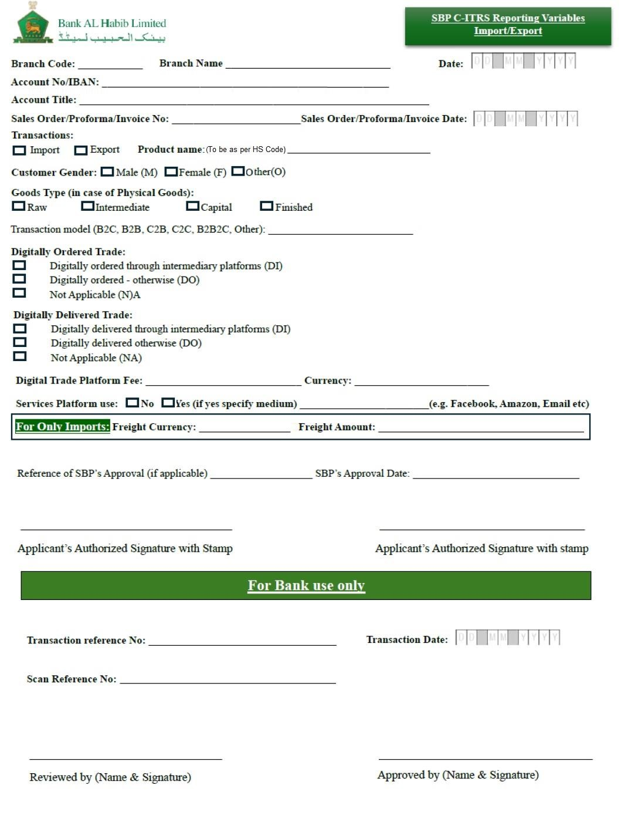

NEW CHALLI
PK84BAHL101500810046070
AGRI COMMODITIES
15610
15
8 0 6 2 0 2 6

1
8 06 2 0 2
6
RICE
USD

